

International School

Capstone Project 2
CMU-SE 450

ARCHITECTURE DESIGN DOCUMENT
Version 1.3
Date: May 5, 2025

SEIMS - Smart Expiry Integration & Management System

Created by C2SE.15
Pham Minh Trang - 28204632177
Nguyen Pham Nhat Huy - 28211100686
Nguyen Huu Thang - 28211102537
Duong Quoc Binh - 28219006390
Nguyen Huy Hoang Bao - 28219004148

Architecture Design Review Panel Representative:

Name Signature Date
Capstone Project 2 - Mentor:

Name MSc.Truong Dinh Huy Signature Date

PROJECT INFORMATION

Project acronym | SEIMS
Project Title | Smart Expiry Integration & Management System
Start Date | February 1, 2026 | End Date |  | April 30, 2026
Lead Institution | International School, Duy Tan University
Project Mentor | MSc.Truong Dinh Huy  Email: huy.truongdinh@gmail.com  Tel: 0982132352
Scrum master / Project Leader & contact details | Pham Minh Trang  Email: pmtrang04@gmail.com  Tel: 0911855450
Partner Organization | Duy Tan University
Team members | Name |  | Email |  | Tel
28204632177 | Pham Minh Trang |  | pmtrang04@gmail.com |  | 0911855450
28211100686 | Nguyen Pham Nhat Huy |  | huy785619@gmail.com |  | 0395546300
28211102537 | Nguyen Huu Thang |  | nguyenhuuthang11@dtu.edu.vn |  | 0702377702
28219006390 | Duong Quoc Binh |  | duongquocbinh@dtu.edu.vn |  | 0932033856
28219004148 | Nguyen Huy Hoang Bao |  | bao91ndu1819@gmail.com |  | 0385092839

DOCUMENT APPROVALS
The following signatures are required for approval of this document.
MSc.Truong Dinh Huy  Mentor | Signature | Date
Pham Minh Trang  Student ID: 28204632177  Project Leader | Signature | Date
Nguyen Pham Nhat Huy  Student ID: 28211100686  Team Member | Signature | Date
Nguyen Huu Thang  Student ID: 28211102537  Team Member | Signature | Date
Duong Quoc Binh  Student ID: 28219006390  Team Member | Signature | Date
Nguyen Huy Hoang Bao  Student ID: 28219004148  Team Member | Signature | Date

DOCUMENT NAME
Document Title | Architecture Design Document
Author(s) | Duong Quoc Binh
Role | Team Member
Date | May 5, 2026 | File name: | 5 C2SE.15_ArchitectureDesign_Ver1.3.doc

REVISION HISTORY
Version | Date | Comments | Author | Approval
1.0 | March 26, 2026 | Create Document | Binh
1.1 | March 27 , 2026 | Update Document | Binh
1.2 | April 17 , 2026 | Update Document | Binh
1.3 | May 11, 2026 | Official Document | Binh

Table of Contents
1.Introduction 2
1.1 Purpose 2
1.2 Document references 2
2. Project Statement 3
2.1. Project definition 3
2.2. Business needs/ User needs 3
2.3. Project Goal 4
3. Architecture Drivers 4
3.1 High-level requirements 4
3.2 System Overview 5
3.3 Quality Attributes 8
4.Constraints 19
4.1 Business Constraints 19
4.2 Technical Constraints 19
5.High-Level Architecture 21
5.1 Component And Connector View (C&C view) 21
5.2 Module view 23
5.3 Allocation View 24
6. System Constraints and Impact Analysis 25
6.1 Problem Complexity Analysis 25
6.2 Engineering Design Constraints 26
6.3 Ethical and Global Impacts 27
7.References 27

1.Introduction

1.1 Purpose
The purpose of this Architecture Design Document (ADD) is to provide a clear and structured description of the software architecture for the Near-Expiry Product Integration & Management Platform for Supermarkets. This document serves as a blueprint that guides the design, development, integration, and deployment of the system, ensuring that all stakeholders share a common understanding of its objectives, structure, and operational scope.
Specifically, this document aims to:
- Define the overall architectural vision of the system, including its core components — Frontend (ReactJS), Backend (Flask API), Database (MySQL), and Cache (Redis) — as well as supporting subsystems such as the Near-Expiry Detection Engine, Discount Rule Engine, Donation Management, Marketplace, and Notification Engine, and their interactions within the System Context.
- Ensure that key Non-Functional Requirements (NFRs) such as: Performance (fast data retrieval, responsive UI, efficient batch processing), Data reliability (prevent selling expired products), Scalability (support multi-supermarket and multi-store architecture), Security (authentication via JWT/OAuth2, role-based access control), Availability and fault tolerance (retry mechanisms, background jobs), are addressed from the early stages of system design.
- Provide architectural guidance for the development team throughout the implementation process, especially regarding: Integration of multiple data sources (Excel/CSV/API), Implementation of automated Near-Expiry Detection using scheduled jobs (Cron), Application of dynamic pricing rules based on product expiry dates, Coordination between B2C (Marketplace) and B2B (Donation) workflows, Event-driven Notification handling across different user roles.
- Establish a solid architectural foundation to support future enhancements such as mobile applications, advanced analytics, AI-based decision support, and integration with external services (e.g., email/SMS, delivery partners).

1.2 Document references

Table 1. Document References
No. | Reference
1 | Product Backlog Document
2 | Project Plan Document
3 | Database Design Document

2. Project Statement

Project definition
The Near-Expiry Product Integration & Management Platform for Supermarkets is a web-based system designed to help supermarket chains efficiently manage and process products that are approaching their expiration dates. The system allows store staff to track inventory at the batch level and automatically detects near-expiry items based on configurable rules.
In addition to inventory management, the platform provides a marketplace for customers to purchase near-expiry products at discounted prices, as well as a donation feature that enables supermarkets to redistribute unsold goods to charity organizations. The system also includes a pricing rule engine to automatically adjust discounts and a notification module to keep users informed about important events.
The platform is built using ReactJS (Frontend), Flask API (Backend), MySQL (Database), and Redis (Cache), with scheduled background jobs (Cron) to ensure real-time detection and efficient system performance.

Business needs/ User needs
Business Needs:
In supermarket operations, especially for perishable goods such as food, beverages, and cosmetics, managing products nearing expiration is a critical challenge. Many supermarkets still rely on manual processes or fragmented systems, leading to poor visibility of expiry dates, inefficient handling of near-expiry items, and increased waste.
As a result, there is a strong need for an integrated and intelligent platform that can:
- Enable automatic detection of near-expiry products based on configurable rules.
- Reduce product waste and financial loss through timely discounting or donation strategies.
- Improve inventory visibility and decision-making with centralized data and real-time monitoring.
- Support multi-store and multi-supermarket management, ensuring scalability and operational efficiency.
- Enhance brand image and social responsibility through structured donation programs.
User Needs:
- Store Staff need an easy-to-use system to manage inventory by batch, receive near-expiry alerts, and handle daily operations such as orders and donations efficiently.
- Supermarket Admins need tools to configure pricing policies, monitor performance across stores, and analyze key metrics such as waste reduction and revenue recovery.
- Customers need a convenient platform to browse and purchase near-expiry products at discounted prices, with clear information and a smooth ordering process.
- Charity Organizations need access to available donation offers and a simple way to request and track donated goods.
- System Administrators need a centralized system to manage users, roles, permissions, and monitor overall system performance.

Project Goal
The primary goal of the Near-Expiry Product Integration & Management Platform for Supermarkets is to digitalize and optimize the management of near-expiry products using a centralized and automated system. The platform aims to help supermarkets detect near-expiry items early, reduce product waste, and maximize revenue recovery.
The system enhances operational efficiency by providing intelligent tools for inventory tracking, dynamic pricing, donation management, and real-time monitoring. By integrating both B2C (discount sales) and B2B (charity donation) models, the platform not only improves business performance but also contributes to social impact.
Ultimately, the project supports the digital transformation of supermarket operations, promoting sustainable retail practices, reducing waste, and improving overall supply chain efficiency.

3. Architecture Drivers

3.1 High-level requirements
(Refer to the Product Backlog document for Beacon)

3.2 System Overview

3.2.1 System Context

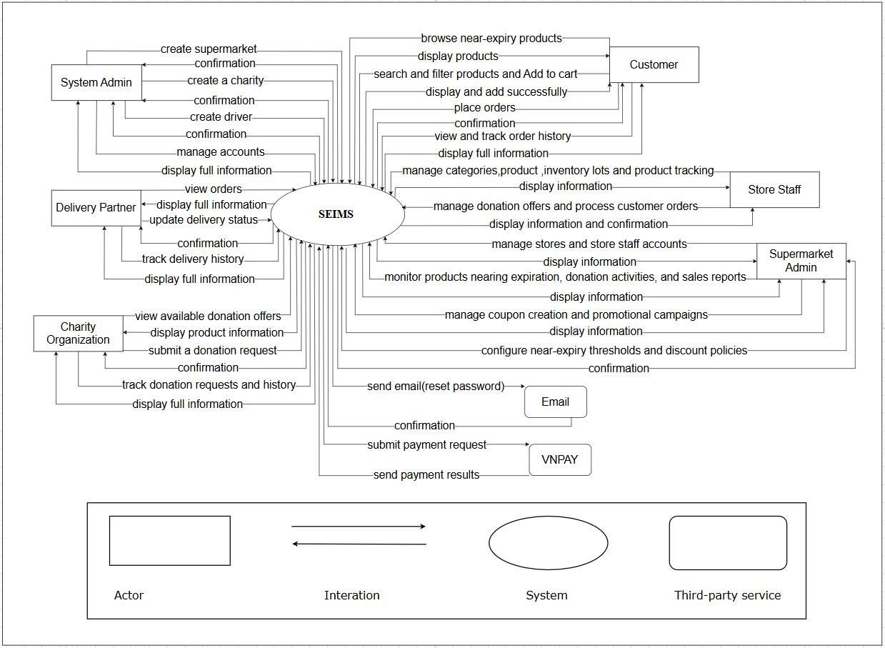

Figure 1. System context overview

3.2.2 System Context description
- System Admin:
- Create supermarkets
- Create charity organizations
- Create delivery partner accounts
- Manage user accounts
- View full system information
- View orders
- Receive confirmation notifications from the system

- Supermarket Admin:
Store & Staff Management:
- Manage stores
- Manage store staff accounts
- View store information
Policy Management:
- Configure near-expiry thresholds
- Configure discount policies
- Manage promotional campaigns and coupons
Monitoring & Reporting:
- Monitor products nearing expiration
- Monitor donation activities
- Monitor sales reports
- View system information
Confirmation:
- Receive confirmation after updates or configurations
- Store Staff:
Inventory Management:
- Manage product categories
- Manage products
- Manage inventory lots
- Track products nearing expiration
Donation & Order Processing:
- Manage donation offers
- Process customer orders
Information Access:
- View detailed information
- Receive confirmations from the system
- Customer:
Product Browsing:
- Browse near-expiry products
- Search and filter products
- Add products to cart
Ordering:
- Place orders
- Receive order confirmation
Tracking:
- View and track order history
- View detailed order information
- Charity Organization:
Donation Activities:
- View available donation offers
- View product information
- Submit donation requests
Tracking:
- Track donation requests
- View donation history
- View detailed information
Confirmation:
- Receive confirmation notification
- Delivery Partner:
- View delivery orders
- View detailed delivery information
- Update delivery status
- Track delivery history
- Receive confirmations
- Email Service (External System):
• SEIMS sends email requests
• Email Service returns confirmation responses
- VNPAY Payment Gateway (External System):
• SEIMS submits payment requests
• VNPAY returns payment results

3.3 Quality Attributes

3.3.1. Use Case Entities

Table 2. Use Case Entity: Store Staff (E01)
ID | E01
Title | Store Staff
Description | End-user responsible for daily store operations, including managing inventory by batch, handling near-expiry products, processing orders, and managing donation activities.
Provides  Assumptions | Provides inventory data (batch, quantity, expiry date) and updates order/donation status.
Requires  Assumptions | Requires login credentials and access to store-level data.
Identified Use Cases | UC01 Login, UC02 Manage Inventory Lot, UC03 View Near-Expiry Alerts, UC04 Create Donation Offer, UC05 Approve Donation Request, UC06 Process Orders, UC07 Update Order Status, UC08 View Dashboard

Table 3. Use Case Entity: Supermarket Admin (E02)
ID | E02
Title | Supermarket Admin
Description | Manages the overall operations of a supermarket chain, including store management, pricing policies, and performance monitoring.
Provides  Assumptions | Provides system configurations such as discount policies, near-expiry thresholds, and user management.
Requires  Assumptions | Requires admin credentials and access to multi-store data within the supermarket.
Identified Use Cases | UC09 Manage Stores, UC10 Manage Staff, UC11 Configure Discount Policy, UC12 Set Near-Expiry Threshold, UC13 View Reports, UC14 Monitor Dashboard

Table 4. Use Case Entity: Customer (E03)
ID | E03
Title | Customer
Description | End-user who browses and purchases near-expiry products through the marketplace.
Provides  Assumptions | Provides order information and interacts with the marketplace.
Requires  Assumptions | Requires a registered account and internet access.
Identified Use Cases | UC15 Register, UC16 Login, UC17 View Products, UC18 Filter Products, UC19 Place Order, UC20 Cancel Order, UC21 View Order History

Table 5. Use Case Entity: Charity Organization (E04)
ID | E04
Title | Charity Organization
Description | Organization that receives donation offers from supermarkets and manages donation requests.
Provides  Assumptions | Provides request information for receiving donated products.
Requires  Assumptions | Requires a registered account and access to donation offers.
Identified Use Cases | UC22 Register, UC23 Login, UC24 View Donation Offers, UC25 Request Donation, UC26 Track Donation Status

Table 6. Use Case Entity: System Admin (E05)
ID | E04
Title | System Administrator
Description | Manages the entire platform, including user accounts, system configuration, and monitoring system performance.
Provides  Assumptions | Provides system-level control, security, and configuration.
Requires  Assumptions | Requires admin credentials and full system access.
Identified Use Cases | UC27 Manage Supermarkets, UC28 Manage Users, UC29 Manage Roles & Permissions, UC30 Monitor System, UC31 View Logs

3.3.2. Operational Use Case

Table 7. Operational Use Case: Register New Account (UC01)
ID | UC01
Title | Register New Account
Description | A new user (Customer or Charity Organization) registers an account to access system features such as purchasing near-expiry products or requesting donations.
Entities  Involved | E03, E04
Preconditions | The user has internet access and is not logged in.
Primary Flow | 1. User navigates to “Register” page.  2. System displays registration form.  3. User enters required information (name, email, password).  4. Click “Register”.  5. System validates input.  6. System stores data in database.  7. Account is created successfully.
Post  Conditions | New account is created and ready to use.
Alternate  Flows | Email exists → Show error. Invalid input → Request correction.

Table 8. Operational Use Case: Login (UC02)
ID | UC02
Title | Login
Description | A registered user logs into the system to access their functions.
Entities  Involved | E01, E02, E03, E04, E05
Preconditions | The user already has a valid registered account.
Primary Flow | 1. User navigates to the login page.  2. Enter email and password.  3. Click Login.  4. System verifies credentials.  5. If valid, user is redirected to the dashboard or homepage.
Post  Conditions | User session is created and stored; user gains access to personal functions.
Alternate  Flows | Invalid credentials → Display error message.  Forgotten password → User clicks “Forgot Password” and receives reset email.

Table 9. Operational Use Case: Manage Inventory Lot (UC03)
ID | UC03
Title | Manage Inventory Lot
Description | Store Staff manages inventory by batch, including adding and updating product lots.
Entities  Involved | E01
Preconditions | Staff is logged in.
Primary Flow | 1. Navigate to inventory module.  2. Add or edit lot information (product, quantity, expiry date).  3. Save data.
Post  Conditions | Inventory data stored in database.
Alternate  Flows | Invalid data → Show validation error.

Table 10. Operational Use Case: Detect Near-Expiry Products (UC04)
ID | UC04
Title | Detect Near-Expiry Products
Description | The system automatically detects products that are close to expiration.
Entities  Involved | System
Preconditions | Inventory data exists.
Primary Flow | 1. Cron job runs.  2. System checks expiry dates.  3. Identify near-expiry products.  4. Update status.
Post  Conditions | Products marked as “Near-Expiry”.
Alternate  Flows | No products found → No action.

Table 11. Operational Use Case: Apply Discount Policy (UC05)
ID | UC05
Title | Apply Discount Policy
Description | System applies discount rules based on remaining shelf life.
Entities  Involved | E02, System
Preconditions | Discount rules configured.
Primary Flow | 1. System calculates remaining days.  2. Apply discount rule.  3. Update product price.
Post  Conditions | Discounted price displayed.
Alternate  Flows | No rule found → Keep original price.

Table 12. Operational Use Case: Place Order (UC06)
ID | UC06
Title | Place Order
Description | Customer places an order for near-expiry products.
Entities  Involved | E03
Preconditions | Customer logged in.
Primary Flow | 1. Browse products.  2. Add to cart.  3. Confirm order.  4. System creates order.
Post  Conditions | Order created successfully.
Alternate  Flows | Out of stock → Show error.

Table 13. Operational Use Case: Process Order (UC07)
ID | UC07
Title | Process Order
Description | Store Staff processes and updates order status.
Entities  Involved | E01
Preconditions | Order exists.
Primary Flow | 1. View orders.  2. Confirm order.  3. Prepare items.  4. Update status.
Post  Conditions | Order updated.
Alternate  Flows | Order canceled → Stop process.

Table 14. Operational Use Case: Manage Donation (UC08)
ID | UC08
Title | Manage Donation
Description | Store Staff creates and manages donation offers.
Entities  Involved | E01, E04
Preconditions | Near-expiry products available.
Primary Flow | 1. Create donation offer.  2. Charity requests.  3. Approve request.
Post  Conditions | Donation completed.
Alternate  Flows | Request rejected.

Table 15. Operational Use Case: View Dashboard & Reports (UC09)
ID | UC09
Title | View Dashboard & Reports
Description | Supermarket Admin monitors system performance and reports.
Entities  Involved | E02
Preconditions | Admin logged in and has access to model management module.
Primary Flow | 1. Open dashboard.  2. View metrics (near-expiry, revenue, donation).
Post  Conditions | Data displayed for analysis.
Alternate  Flows | No data → Show empty state.

Table 16. Operational Use Case: Manage System (UC10)
ID | UC10
Title | Manage System
Description | System Admin manages users, roles, and system configuration.
Entities  Involved | E05
Preconditions | Admin logged in.
Primary Flow | 1. Access admin panel.  2. Manage users/roles.  3. Monitor system.
Post  Conditions | System updated.
Alternate  Flows | Unauthorized access → Denied.

3.3.3. Quality attributes

Table 17. Quality Attribute: Usability (QA01)
Quality attribute:  Usability | ID:QA01
Stimulus | A new user (Customer or Store Staff) accesses the system for the first time to browse products or manage inventory.
Source(s) of the Stimulus | Customer (E03), Store Staff (E01)
Relevant Environment | Runtime (web application usage).
Artifact Stimulated | Web user interface (ReactJS).
Response | The system provides a simple and intuitive workflow (login → browse/manage → action → result) with clear navigation and user guidance.
Response Measure(s) | A new user can complete a basic task (place order or add inventory lot) within 3 minutes. ≥ 90% of users complete tasks without assistance.

Table 18. Quality Attribute: Performance (QA02)
Quality attribute: Performance | ID: QA02
Stimulus | A user performs actions such as browsing products, placing orders, or loading dashboard data.
Source(s) of the Stimulus | Customer, Store Staff, Admin
Relevant Environment | Runtime under normal and peak load.
Artifact Stimulated | Backend API, database, Redis cache.
Response | The system processes requests and returns results quickly and efficiently.
Response Measure(s) | API response time ≤ 2 seconds for normal requests. ≤ 5 seconds for complex queries (dashboard/report). Maintain response time < 6 seconds for 95% of requests during peak load

Table 19. Quality Attribute: Accuracy (QA03)
Quality attribute:  Accuracy | ID: QA03
Stimulus | The system processes inventory data and detects near-expiry products.
Source(s) of the Stimulus | System (Cron Job), Store Staff
Relevant Environment | Runtime and scheduled processing.
Artifact Stimulated | InventoryLot data, Near-Expiry Detection Engine.
Response | The system ensures accurate detection and prevents expired products from being sold.
Response Measure(s) | 100% of expired products are blocked from sale. ≥ 95% accuracy in near-expiry detection based on configured rules.

Table 20. Quality Attribute: Security (QA04)
Quality attribute:  Security | ID: QA04
Stimulus | A user logs in, places an order, or accesses sensitive system data.
Source(s) of the Stimulus | All users (E01–E05)
Relevant Environment | Runtime under normal and adverse conditions.
Artifact Stimulated | Authentication module, backend API, database.
Response | The system protects user data and prevents unauthorized access.
Response Measure(s) | 100% of requests use HTTPS (TLS 1.2+).  Passwords are hashed before storage.  Role-Based Access Control (RBAC) enforced for all actions.

Table 21. Quality Attribute: Maintainability (QA05)
Quality attribute:  Maintainability | ID: QA05
Stimulus | Developers update system modules (e.g., pricing engine, inventory, or notification)
Source(s) of the Stimulus | Developer / Administrator
Relevant Environment | Maintenance phase or post-deployment.
Artifact Stimulated | Backend services, APIs, database schema.
Response | The modular architecture allows updates without affecting other components.
Response Measure(s) | ≥ 80% of updates do not impact other modules. Mean Time To Repair (MTTR) < 4 hours for non-critical issues.

Table 22. Quality Attribute: Scalability (QA06)
Quality attribute:  Scalability | ID: QA06
Stimulus | The number of users and transactions increases significantly across multiple supermarkets and stores.
Source(s) of the Stimulus | System load (customers, staff, admins).
Relevant Environment | Runtime under high load.
Artifact Stimulated | Backend API, database, Redis cache, server infrastructure.
Response | The system scales to handle increased load while maintaining stable performance.
Response Measure(s) | Handle ≥ 500 concurrent users without failure. Throughput degradation ≤ 15% under peak load. System uptime ≥ 95%.

4.Constraints

4.1 Business Constraints

Table 23. Business Constraints
ID | Title | Description
BC01 | Time Constraints | The system must be developed, tested, and ready for demonstration within a 3-month timeframe (from February 1 to April 30, 2026) in accordance with the Capstone Project 1 schedule.
BC02 | Budget Constraints | The total estimated project cost must not exceed $2,560, including development labor, testing, hosting, and other operational expenses.
BC03 | Resource Constraints | The development team consists of 5 members, each with predefined Scrum roles(Scrum Master, Team Depvelopment, Product Owner) . Efficient coordination and task allocation are required to meet sprint deadlines.
BC04 | Target Audience | The system is designed for supermarket staff, administrators, customers, and charity organizations, requiring a user-friendly interface, clear workflows, and accessibility across common devices and browsers.
BC05 | Scalability Constraints | Although developed as a Capstone prototype, the system architecture must be modular and extensible to support future expansion such as multi-supermarket scaling, mobile applications, and advanced analytics.
BC06 | Technology Constraints | The system must be built using web-based and open-source technologies such as ReactJS, Flask API, MySQL, and Redis. It should run efficiently on standard infrastructure without requiring specialized hardware, and be deployable using Docker-based environments.

4.2 Technical Constraints

Table 24. Technical Constraints
Constraint | Description | Rationale (Reason for Choice)
Backend Technology: (Python) | The backend is implemented using FastAPI, a modern, high-performance Python web framework for building RESTful APIs. | Flask is simple, flexible, and suitable for rapid development in a Capstone project, while still supporting modular architecture and integration with background jobs (Cron).
Frontend Technology: ReactJS | The user interface is developed with ReactJS for building dynamic and interactive Single Page Applications (SPA). | ReactJS enables reusable components, fast UI updates, and seamless interaction with backend APIs, improving user experience for staff and customers.
Database: MySQL | MySQL is used as the primary relational database for storing system data such as users, products, inventory lots, orders, and donations. | MySQL is stable, open-source, and well-suited for structured data and transactional operations in inventory and order management systems.
Cache: Redis | Redis is used as an in-memory cache to improve performance for frequently accessed data. | Redis helps reduce database load, speeds up product listing and dashboard queries, and enhances system responsiveness.
Authentication: JWT (JSON Web Token) | The system uses JWT for secure and stateless authentication. | JWT enables token-based authentication between client and server, ensuring session scalability and minimal backend overhead.
Deployment: Docker + Nginx | The system is containerized using Docker and deployed with Nginx as a reverse proxy. | Docker ensures consistent environments across development and deployment, while Nginx improves performance, routing, and scalability.
Background Processing: Cron Jobs | Scheduled jobs are used to detect near-expiry products and trigger system events. | Cron provides a simple and effective way to automate periodic tasks without requiring complex event-driven infrastructure.
Hosting: Cloud Server (AWS / GCP / VPS) | The system is deployed on a cloud-based server for remote access and testing. | Cloud hosting ensures availability, scalability, and easy deployment for demonstration and future expansion.
Version Control: GitHub | Source code and documentation are hosted on GitHub under a private repository. | GitHub ensures code versioning, collaboration, and continuous integration among the 5 team members.
Project Management Tools: Jira, Trello, Zalo, Google Drive | The team uses Jira for sprint tracking, Trello for task management, and Zalo/Drive for communication and document sharing. | These tools support Scrum methodology, enhance coordination, and ensure transparency across sprints.

5.High-Level Architecture

Component And Connector View (C&C view)
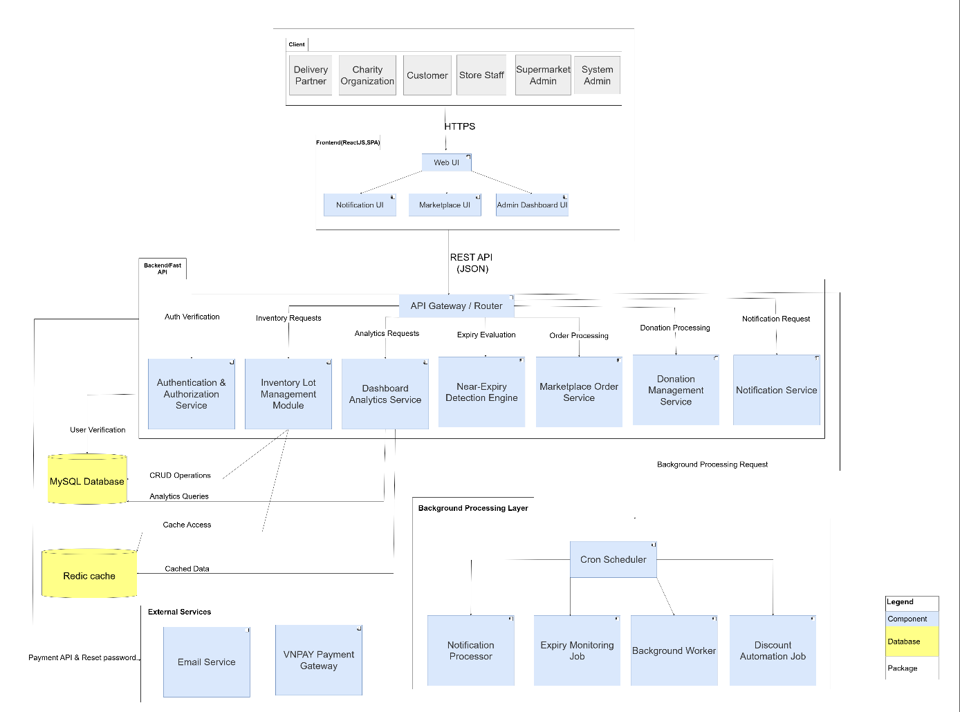
Figure 2. HMS C&C View

Prose: The SEIMS system architecture follows a multi-layered Component and Connector (C&C) design consisting of Client, Frontend, Backend, Background Processing, Data, and External Service layers. Users such as customers, supermarket administrators, store staff, charity organizations, delivery partners, and system administrators access the system through a ReactJS-based web interface.
The frontend communicates with the FastAPI backend via RESTful APIs using JSON over HTTPS. The backend manages core functionalities including authentication, inventory lot management, near-expiry detection, marketplace orders, donation management, notifications, and analytics. Background processing components handle scheduled tasks such as expiry monitoring and discount automation.
MySQL Database and Redis Cache are used for data storage and performance optimization, while external services such as Email Service and VNPAY Payment Gateway support password recovery and payment processing. This modular architecture improves system scalability, maintainability, and operational efficiency.
Table 25. Component And Connector View
Role | Responsibility
Web Application (ReactJS SPA) | Provides the user interface for customers, supermarket administrators, store staff, charity organizations, delivery partners, and system administrators. Handles product browsing, inventory management, donation activities, dashboard monitoring, and order processing through a secure web interface.
API Gateway/  Router(Fast API) | Serves as the central entry point for all client requests. Routes API requests to appropriate backend services and manages request validation, authentication, and communication between system components.
Authentication & Authorization Service | Handles user authentication, JWT-based authorization, password reset operations, and access control for all system users.
Inventory Lot Management Module | Manages product inventories, inventory lots, stock updates, product tracking, and CRUD operations related to near-expiry products.
Near-Expiry Detection Engine | Monitors product expiration dates and evaluates near-expiry status to support discount automation and inventory management processes.
Marketplace Order Service | Processes customer orders, order tracking, and payment-related operations through integration with the VNPAY Payment Gateway.
Donation Management Service | Manages donation offers, donation requests, and coordination between supermarkets and charity organizations.
Dashboard Analytics Service | Provides analytics, sales reports, inventory statistics, and operational dashboards for administrators and store managers.
MySQL Database | Stores structured system data including users, products, inventory lots, orders, donation records, and audit logs.
Redis Cache | Provides temporary data caching and improves system performance for frequently accessed data and analytics queries.
External Service: Email Service | Sends password reset and account-related emails securely to system users.
External Service: VNPAY Payment Gateway | Supports secure online payment processing for marketplace transactions.

5.2 Module view

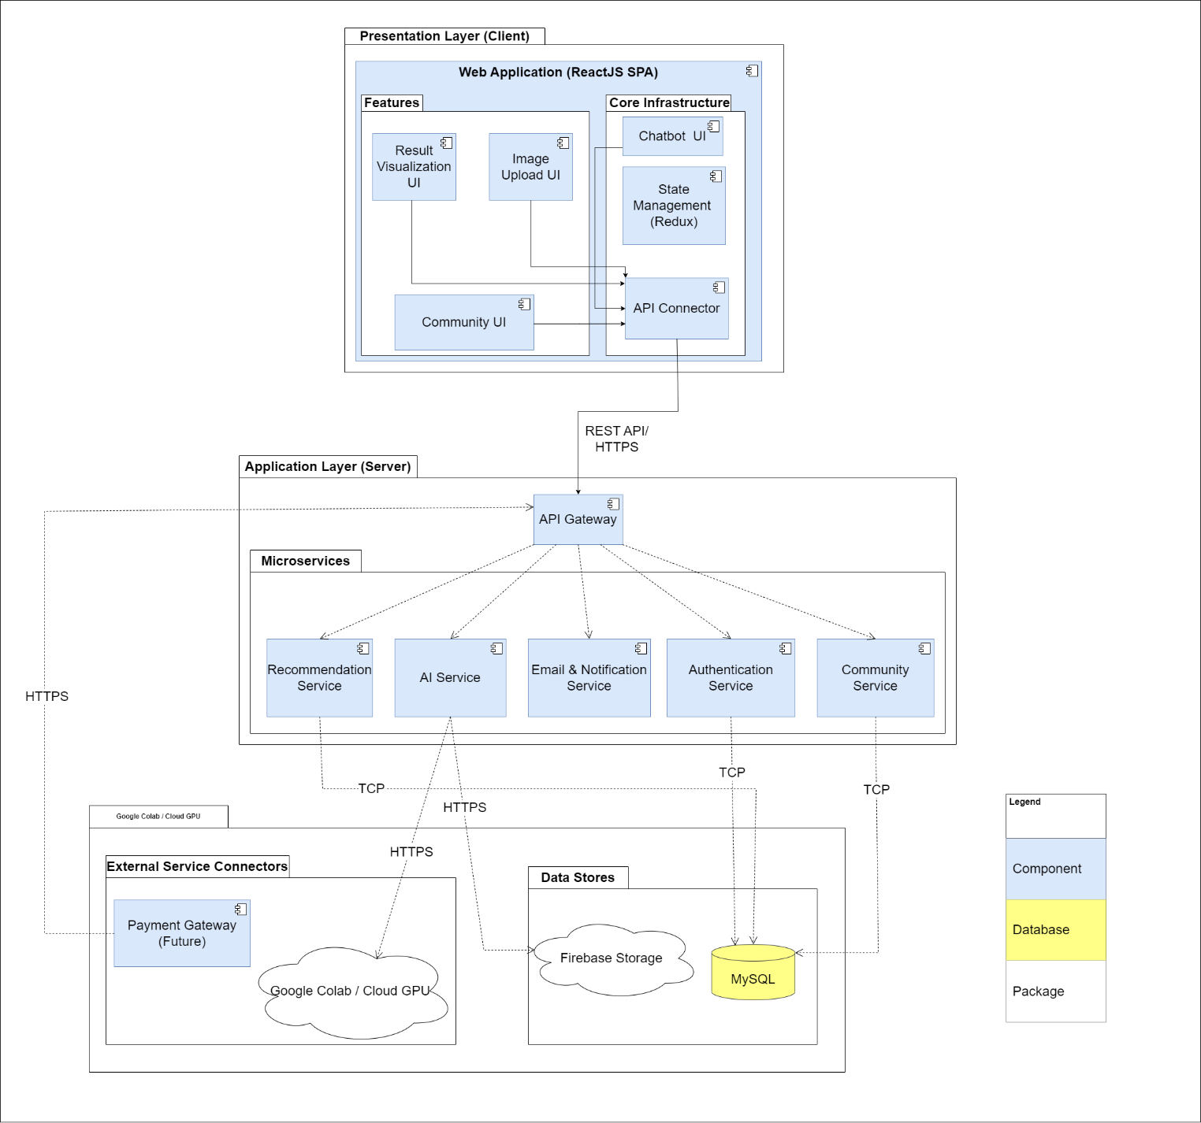
Figure 3. HMS Module View

Prose: This view organizes the system into three distinct layers: Presentation, Application, and Infrastructure. Each layer groups its modules by responsibility, ensuring a clear separation of concerns across the architecture. The Presentation Layer contains the ReactJS UI modules that handle user interactions, while the Application Layer defines backend modules such as authentication, AI services, community management, and recommendations.
The Infrastructure Layer provides foundational support through data storage, external AI training resources, and supporting services such as Firebase and MySQL. This layered structure enhances maintainability and modifiability by allowing updates or replacements in one layer—such as improving the user interface or updating the AI model—without introducing changes to the other layers. It supports clean code organization, easier debugging, and scalable future expansion.

5.3 Allocation View
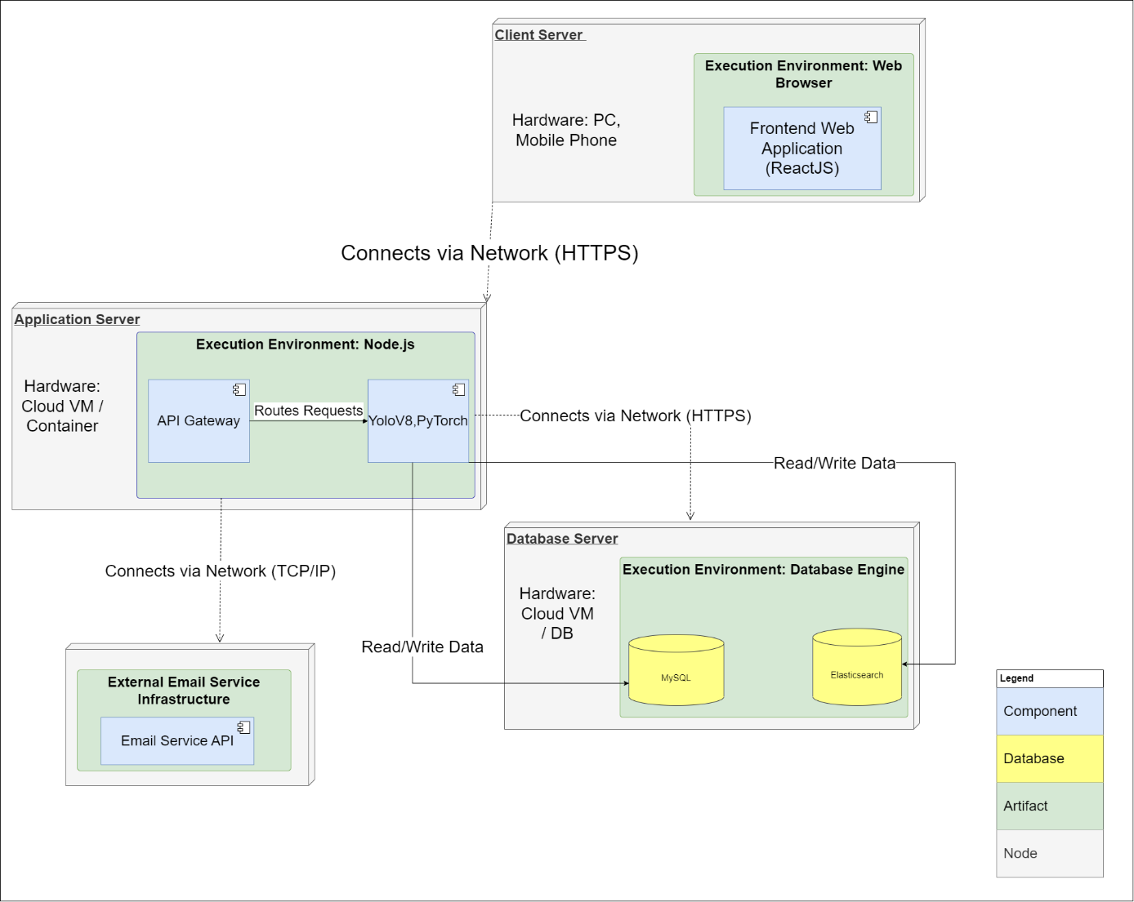
Figure 4. HMS Allocation View

Prose: The Allocation View describes how LeafSense is deployed across its physical and execution environments. The system runs on three main nodes: the Client Device, the Application Server, and the Database Server, with an additional External Email Service.
On the Client Device, the Web Browser executes the ReactJS Frontend Web Application, handling all user interactions. It communicates with the backend exclusively through secure HTTPS.
The Application Server, deployed on a cloud VM or container, uses a Node.js execution environment. Inside this environment, the API Gateway routes all incoming requests, while the YOLOv8/PyTorch module performs AI-based image analysis. This server acts as the central processing unit of the system.
The Database Server hosts MySQL and Elasticsearch within a database engine environment. MySQL stores transactional data, while Elasticsearch supports fast searching and indexing. The Application Server interacts with the database through TCP/IP for all read/write operations.
Finally, an External Email Service handles password reset and notification emails. The Application Server communicates with this service externally via TCP/IP.
Overall, the allocation shows a clear distribution: UI on the client, logic and AI on the application server, persistent storage on the database server, and email processing offloaded to an external service.

6. System Constraints and Impact Analysis

6.1 Problem Complexity Analysis
The core technical challenge of the SEIMS (Smart Expiry Product Integration & Management System) project lies in managing near-expiry products in real time while maintaining system scalability, data consistency, and operational efficiency across multiple supermarkets and stakeholders. The system must continuously monitor inventory lots, evaluate expiration dates, automate discount calculations, process marketplace orders, and coordinate donation activities simultaneously.
Another major complexity is balancing performance and accuracy in the near-expiry detection and automated discount workflows. The architecture must support asynchronous background processing to handle scheduled expiry monitoring and discount automation without affecting user experience or system responsiveness. To address these challenges, the project applies a layered Component and Connector (C&C) architecture using FastAPI, ReactJS, MySQL, Redis Cache, and background job scheduling mechanisms. RESTful APIs and modular service separation improve scalability, maintainability, and efficient runtime communication between components.

6.2 Engineering Design Constraints
To ensure the system is reliable and practical in real-world supermarket operations, the architecture design addresses several important engineering constraints:
• Public Health, Safety, and Welfare
The system protects user privacy and operational security through JWT-based authentication, role-based access control (RBAC), and encrypted password storage. Different stakeholders such as customers, supermarket administrators, store staff, and charity organizations are restricted to authorized functions only. In addition, fail-safe background processing mechanisms help prevent complete system failure when scheduled jobs or external services experience temporary interruptions.
• Economic Factors
The project architecture is designed to minimize deployment and operational costs by utilizing lightweight FastAPI services, Redis caching, and modular backend components. The use of RESTful APIs and centralized service management reduces infrastructure complexity and supports future scalability without requiring expensive enterprise infrastructure.
• Environmental Factors
SEIMS contributes to reducing food waste by identifying near-expiry products early and supporting automated discount campaigns and donation workflows. The system architecture also optimizes server resource usage through asynchronous background jobs and caching mechanisms, reducing unnecessary CPU and database workloads.
• Social and Cultural Factors
The platform supports interactions among supermarkets, customers, delivery partners, and charity organizations to encourage sustainable consumption and social responsibility. The user interface is designed to be simple and accessible for different user groups, improving usability and operational efficiency in retail environments.

6.3 Ethical and Global Impacts
• Ethical Impacts and Data Privacy
The system handles sensitive operational and customer data, making data privacy and security critical concerns. Passwords are securely encrypted, authentication tokens are validated through JWT mechanisms, and role-based permissions restrict unauthorized access. The project also minimizes risks of data misuse by limiting access to inventory, donation, and customer information.
• Intellectual Property and Legal Considerations
The project utilizes open-source technologies and frameworks including ReactJS, FastAPI, MySQL, and Redis. All external libraries and APIs are used according to their respective licenses and documentation. In addition, secure backend APIs and authentication mechanisms help reduce risks related to unauthorized access and reverse engineering.
• Global and Societal Impacts
If deployed at large scale, SEIMS can contribute significantly to reducing food waste, improving supermarket inventory efficiency, and supporting charitable donation activities. By helping supermarkets manage near-expiry products more effectively, the system promotes sustainable retail operations and creates positive social impacts for communities and environmental sustainability.

7.References
[1] Docker: https://www.docker.com
[2] FastAPI: https://fastapi.tiangolo.com
[3] Spring: https://spring.io/
[4] Draw

